Full Stack Engineering

Project Report Semester-V (Batch-2022)

**MindWhisper**



**Supervised By: Submitted By:**

Mr. Rahul Singh Rajput Arushika-2310990301(G-4)

Vishal Mishra-2310991363(G-4) Muskan-2310991416(G-4) Nandini Sharma-2310991420 (G-4)

**Department of Computer Science and Engineering Chitkara University Institute of Engineering & Technology,**

**Chitkara University, Punjab**

# ABSTRACT

**MindWhisper** is an interactive mental health platform designed to provide accessible, secure, and anonymous support for users, volunteers, and consultants. The system integrates AI-driven recommendations, real-time chat, and personalized resources such as books, music, mindfulness exercises, and wellness videos. It aims to create a stigma-free digital ecosystem where individuals can seek help, track their progress, and engage with a supportive community.

The platform leverages advanced technologies including AI-powered sentiment analysis, mood tracking, and real-time chat systems with anonymity options, combined with end-to-end data encryption to ensure privacy and reliability. Through intelligent recommendations, users gain access to self-care strategies, wellness tools, and professional guidance tailored to their needs. An interactive dashboard enhances user experience, enabling seamless interaction between users, consultants, and volunteers.

Built on a scalable MERN stack architecture, the platform supports high user traffic while maintaining performance efficiency. Integration with cloud services (AWS/Firebase) ensures smooth data handling, while WebSockets enable instant communication for real-time support.

This report outlines the project background, problem statement, objectives, methodology, results, and future scope, highlighting how MindWhisper addresses key challenges in mental health accessibility while ensuring a personalized, secure, and empathetic user experience.

# Table of Contents

|  |  |  |
| --- | --- | --- |
| **SR.NO** | **TOPIC** | **PAGE NO** |
| 1. | Introduction | 4-8 |
| 2. | Problem Definition and Requirements | 9-11 |
| 3. | Proposed Design/Methodology | 12-16 |
| 4. | Results | 16-18 |
| 5. | References | 21 |

# Introduction

**MindWhisper** is an interactive, web-based mental health support platform designed to provide users with a safe, supportive, and personalized space for managing their well-being. Built using the **MERN stack (MongoDB, Express.js, React.js, Node.js)**, MindWhisper integrates AI-driven recommendations, real-time chat features, and secure resource sharing to create a seamless and user-centred experience.

The platform consists of several key sections that enable smooth navigation and meaningful engagement:

**Signup Page**

The **Signup Page** allows new users to join the MindWhisper community by providing essential details such as name, email, and password. Input validation ensures accuracy, while secure registration guarantees privacy. After successful sign-up, users gain access to the platform’s core features.

**Login Page**

The **Login Page** provides registered users with a secure gateway to access their personalized dashboard. Robust session management and encryption protect user credentials and maintain the integrity of accounts during their interactions.

**Home Dashboard**

The **Home Dashboard** acts as the central hub of MindWhisper. It provides users with personalized wellness feeds, AI-recommended content such as articles, videos, or relaxation music, and easy access to chat options. This page ensures users can quickly connect with resources and community members.

**Chat & Support Page**

The **Chat Page** offers **real-time messaging** with consultants, volunteers, or AI-powered chatbots. Users can seek immediate support, share concerns, and receive guidance in a secure and anonymous environment, helping them feel connected and supported at all times.

**My Profile Page**

The **My Profile Page** gives users a personalized overview of their activities and progress. It displays saved resources, recent chats, personalized recommendations, and wellness goals. This page helps users track their journey, ensuring they remain engaged and motivated in their mental health improvement.

In summary, **MindWhisper** offers a comprehensive and engaging mental health support environment. By combining a robust backend with an intuitive frontend, the platform enables users to access personalized wellness resources, connect with consultants, and interact with supportive communities.

## Background

**• Signup Page**

The **Signup Page** serves as the entry point for new users to join the **MindWhisper** community. It presents a clean, intuitive form where individuals provide essential details such as **name, email, and password**. The system validates all inputs to ensure uniqueness and compliance with security standards, protecting user data from unauthorized access.

* **Name/Username:** A unique identifier displayed in chats and profiles, ensuring personal recognition within the platform.
* **Email:** Used for secure account verification, notifications, and password recovery.
* **Password:** Encrypted using secure hashing techniques (e.g., bcrypt) to safeguard credentials.

Upon submission, the platform checks for duplicate entries or invalid formats. Successful registration directs users to the **Login Page**, laying the foundation for a secure and personalized user journey.

**• Login Page**

The **Login Page** allows existing users, volunteers, or consultants to securely access their accounts. Authentication requires a registered **email and password**, which are validated against the system database.

* **Email and Password:** Essential for login, with credentials stored using encryption for privacy.
* **Forgot Password (optional):** Enables secure password reset via registered email.
* **Session Management:** Ensures unique and protected sessions, preventing unauthorized access.

This page ensures privacy, offering safe entry to personalized dashboards and maintaining smooth session control throughout the user’s activities.

**• Home Dashboard**

The **Home Dashboard** acts as the **central hub of MindWhisper**, offering a personalized view of wellness resources and community features. Users can access their **personalized wellness feed**, connect with consultants, or explore shared resources.

* **Personalized Feed:** AI-driven suggestions for resources such as self-care tips, meditation guides, and motivational content.
* **Quick Access to Chat:** Users can instantly connect with the chatbot, volunteers, or consultants.
* **Discover Resources:** Explore trending books, videos, or wellness tools tailored to user preferences.

This page promotes **active engagement**, ensuring a welcoming and stress-free environment for all users.

**• Chat & Support Page**

The **Chat Page** enables **real-time interaction** through instant messaging, allowing users to communicate with consultants, volunteers, or AI-powered chatbots. Anonymity options are included to encourage open and stigma-free discussions.

* **AI Chatbot:** Provides 24/7 instant guidance, mood tracking, and coping strategies.
* **Volunteer/Consultant Chat:** Real-time messaging with human supporters for empathetic guidance.
* **Anonymity Mode:** Allows users to hide their identity while seeking support.

This page serves as the **core support system**, ensuring timely help and building trust within the community.

**• My Profile Page**

The **My Profile Page** provides a personalized overview of a user’s activities and progress. It centralizes personal information, saved resources, and engagement with the platform.

* **Saved Resources:** Displays bookmarked videos, music, or articles for easy access.
* **Wellness Journey Tracker:** Shows activity history, mood logs, and progress indicators.
* **Profile Information:** Includes basic user details with the option to manage and update account settings.

**1.2 Objectives**

The primary objectives of the **MindWhisper mental health support platform** are as follows:

**1. User Engagement and Support**

* MindWhisper encourages users to actively engage with wellness resources, personalized recommendations, and real-time chat.
* The platform fosters a **supportive, stigma-free environment** where users can connect with consultants, volunteers, and peers for guidance and encouragement.

**2. Secure User Authentication**

* The platform ensures **safe and private access** through secure signup and login systems.
* User credentials are protected with **encryption and session management**, guaranteeing confidentiality and trust for all participants.

**3. Personalized Wellness Recommendations**

* MindWhisper leverages **AI-driven recommendations** to provide users with tailored self-care tips, wellness exercises, and curated content such as music, books, and motivational videos, ensuring a unique experience for each individual.

**4. Real-Time Chat and Emotional Support**

* The system provides **instant messaging** with AI chatbots, volunteers, and consultants.
* Features such as **anonymity mode** and **24/7 availability** ensure users feel safe, heard, and supported during their mental health journey.

**5. Profile and Progress Tracking**

* Each user has a **dedicated profile page** displaying their saved resources, activity history, and wellness progress.
* This allows individuals to reflect on their journey, stay motivated, and monitor improvements over time.

**6. Scalable Cloud-Based Architecture**

* Built with the **MERN stack** and integrated with cloud services, MindWhisper ensures **scalability, security, and high availability**.
* The flexible backend can handle growing traffic and adapt to evolving user needs.

**7. User-Centric Design and Usability**

* MindWhisper emphasizes a **responsive and intuitive interface**.
* With simple navigation, minimal stress-inducing elements, and mobile accessibility, the platform ensures a smooth and supportive user experience across devices.

**2. Problem Definition and Requirements**

**1. Limited Access to Mental Health Support**

* Many individuals avoid or delay seeking professional help due to **stigma, high costs, or lack of availability**.
* Existing digital platforms are either too generic or limited, leaving users without personalized and accessible mental health resources.

**2. Difficulty in Engaging Users in Supportive Communities**

* Current mental health apps often focus on self-help content but lack **interactive features** that foster real human connection.
* Users have limited opportunities to connect with peers, volunteers, or consultants, which reduces the sense of community and belonging.

**3. Lack of Personalized Guidance and Recommendations**

* Many platforms provide static, one-size-fits-all resources.
* Users need **AI-driven, personalized recommendations** (such as relaxation techniques, articles, or music) tailored to their mood, interests, and progress.

**4. Challenges in Tracking Mental Health Progress**

* Users often lack tools to **monitor their emotional journey** over time.
* A personal dashboard that records saved resources, chats, and mood tracking is needed to encourage reflection and consistent improvement.

**5. Security and Privacy Concerns**

* Mental health data is highly sensitive, and weak authentication or storage can lead to breaches of trust.
* Ensuring **end-to-end encryption, secure login, and anonymous interaction options** is critical to protecting user identity and data.

**6. Scalability and Performance Issues**

* As user numbers increase, platforms without a robust backend may face **latency, downtime, or data management bottlenecks**.
* A **cloud-based, scalable architecture** is required to handle real-time chats, high traffic, and growing data securely.

**7. Community Engagement and Fair Support**

* Many existing apps lack **transparent and accessible ways** for consultants, volunteers, and users to interact meaningfully.
* A balanced ecosystem is required where users can receive guidance, share experiences, and build supportive networks without bias.

**Software Requirements**

To develop the MindWhisper mental health support platform, the following software and tools were used:

**1. Programming Languages**

* JavaScript (Full Stack Development):
  + Node.js is used for backend development, enabling server-side JavaScript execution with an asynchronous, event-driven architecture, ideal for handling multiple real-time chats, AI-driven requests, and user interactions.
  + React.js (Frontend Framework): Used for building a responsive, component-based UI with dynamic rendering, ensuring smooth navigation and minimal load times for users.
  + Client-Side JavaScript: Handles interactive features such as chat responses, bookmarking resources, and dynamic filtering of wellness content.
* HTML5 & CSS3:
  + HTML5 structures the web pages and interfaces.
  + CSS3 ensures styling, responsiveness, and a visually calming design suitable for mental health users.
  + Tailwind CSS / Bootstrap (if used): Provides pre-designed UI components and responsive layouts for faster development and a professional interface.

**2. Frameworks and Libraries**

* Node.js:
  + Provides the server-side runtime environment, managing API requests, chat connections, and data exchange efficiently.
* Express.js:
  + A minimal and flexible Node.js framework, handling routing, middleware, and RESTful APIs, forming the backbone of MindWhisper’s backend services.
* React.js:
  + Powers the frontend UI, ensuring real-time rendering, responsive layouts, and interactive features such as chat windows, dashboards, and recommendation feeds.
* MongoDB with Mongoose:
  + MongoDB (NoSQL Database): Stores user profiles, chat histories, resources, wellness logs, and recommendations.
  + Mongoose: Provides schema modelling, validation, and relationships between documents, ensuring scalable and organized data storage.
* AI & Utility Libraries (optional if implemented):
  + TensorFlow.js / NLP Libraries: Used for basic sentiment analysis and AI-driven content recommendations.
  + bcrypt.js: For password hashing and encryption.
  + JWT (JSON Web Token): For secure authentication and session management.
  + Socket.io / WebSockets: Enables real-time chat and instant notifications between users, consultants, and volunteers.

**3. Development and Version Control Tools**

* Git:
  + Used for version control, tracking code changes and enabling collaborative development.
* GitHub / GitLab:
  + Hosts the project repository for team collaboration, code reviews, and CI/CD pipelines if needed.
* Visual Studio Code (VS Code):
  + The primary IDE for writing, debugging, and managing the project codebase, with plugins for React, MongoDB, and Node.js integration.

**4. Browsers and Client-Side Requirements**

* Google Chrome / Mozilla Firefox / Safari / Microsoft Edge:
  + MindWhisper is fully compatible with all major browsers, ensuring a consistent and accessible experience across platforms.
* Responsive Design Support:
  + Optimized for desktop, tablet, and mobile devices, allowing users to access the platform anytime, anywhere.

**5. Development Environment**

* Node.js (v14.x or later):
  + Required to run the backend and ensure compatibility with modern frameworks and libraries.
* NPM (Node Package Manager):
  + Manages dependencies including Express.js, React libraries, Socket.io, bcrypt, and other packages.
* Cloud Services (AWS / Firebase / Google Cloud):
  + Used for scalable hosting, database storage, backups, and real-time notification

**3. Proposed Design and Methodology**

This section outlines the proposed design and methodology for the development of *MindWhisper*, a mental health support platform that connects users with supportive communities, AI-driven resources, volunteers, and consultants. The design emphasizes empathy, accessibility, and engagement, while the methodology follows a structured approach to ensure security, personalization, and scalability.

**Proposed Design**

The design of *MindWhisper* focuses on providing a clean, calming, and user-friendly interface with intuitive navigation. The main components of the platform include:

**1. Home Page**

The landing page introduces users to *MindWhisper*, offering quick access to resources, community forums, and mood-based recommendations. It also provides entry points for login, signup, or anonymous browsing.

* Highlights featured articles, calming music, and motivational stories.
* Displays trending discussions or popular resources from the community.

**2. Login/Signup Page**

A secure authentication system that allows users to register or log in. The design includes options for both full registration and anonymous access, ensuring inclusivity.

* Fields for username, email, and password (with secure hashing).
* Option for anonymous or “guest mode” entry for users hesitant to share details.
* Secure session management for data protection.

**3. Resource & Recommendation Page**

A dedicated section where users can access personalized mental health resources such as relaxation exercises, articles, guided meditation, or mood-lifting content.

* AI-driven recommendation system that tailors resources to user mood, history, and preferences.
* Options to save, share, or bookmark resources for later use.

**4. Community Support Page**

An interactive space where users can connect with peers, volunteers, and consultants.

* Features discussion threads, Q&A forums, and chat support.
* Provides emotional peer support while ensuring respectful and safe communication.
* Includes moderated spaces to prevent harmful interactions.

**5. User Profile Page**

A personalized dashboard for each user to track their activity, progress, and engagement.

* Displays saved resources, chat history, and participation in discussions.
* Tracks user mood over time (via self-input or AI prompts).
* Provides privacy controls so users can decide what to share with the community.

**6. Consultant/Volunteer Portal**

A specialized area for registered consultants and volunteers to interact with users.

* Allows consultants to offer advice and resources.
* Volunteers can provide peer-to-peer support in moderated environments.
* Includes reputation or feedback metrics to maintain quality support.

# Results

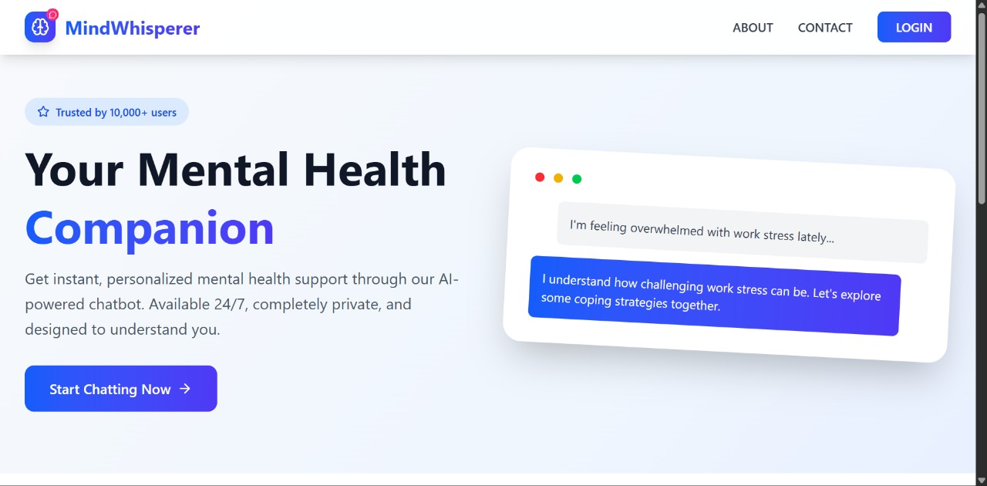

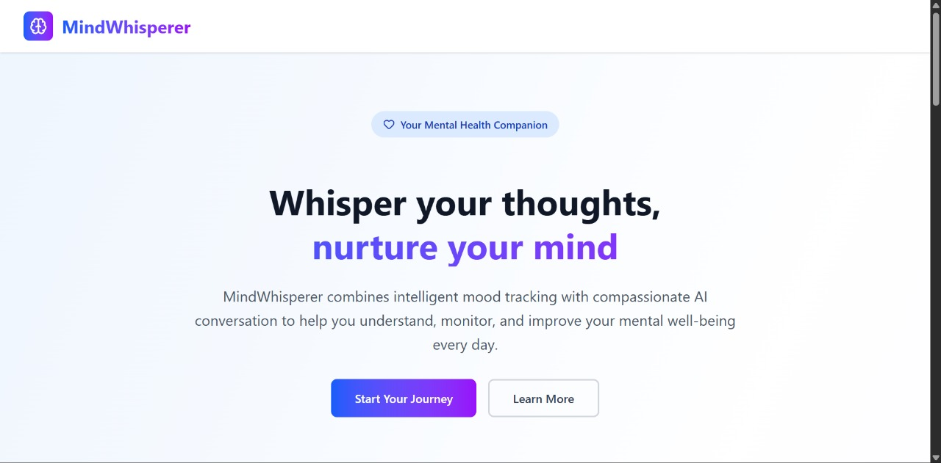

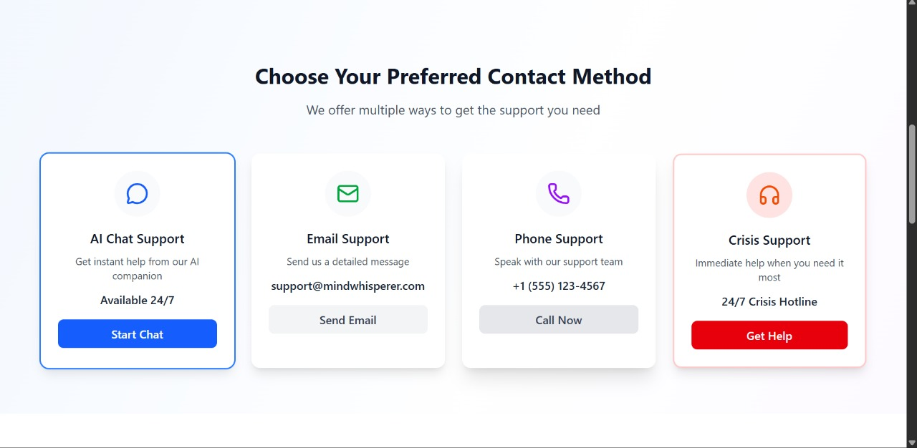

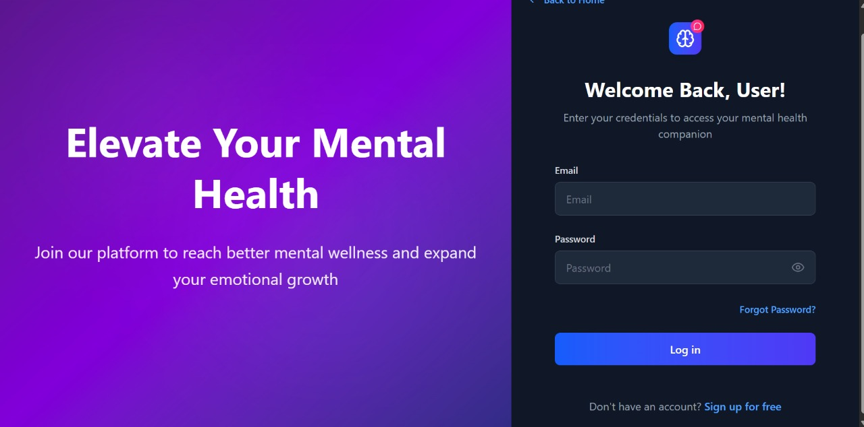

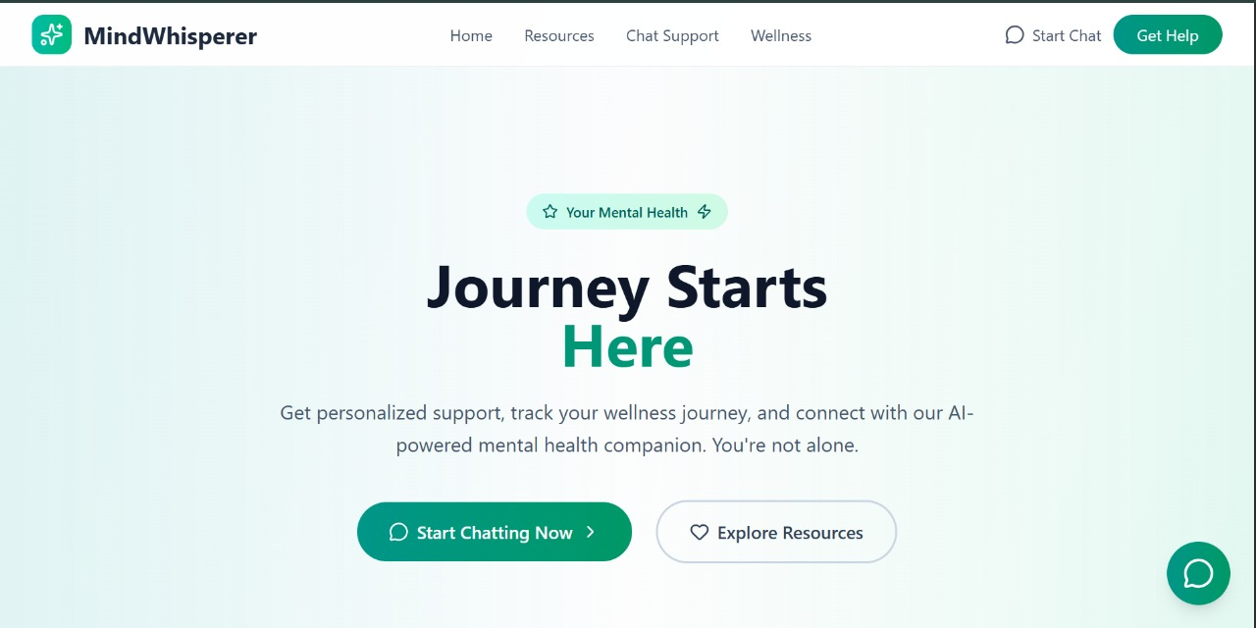

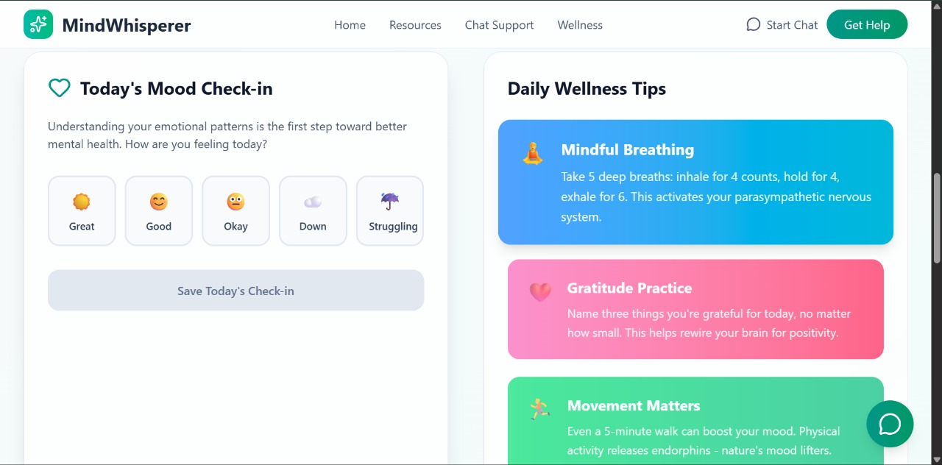

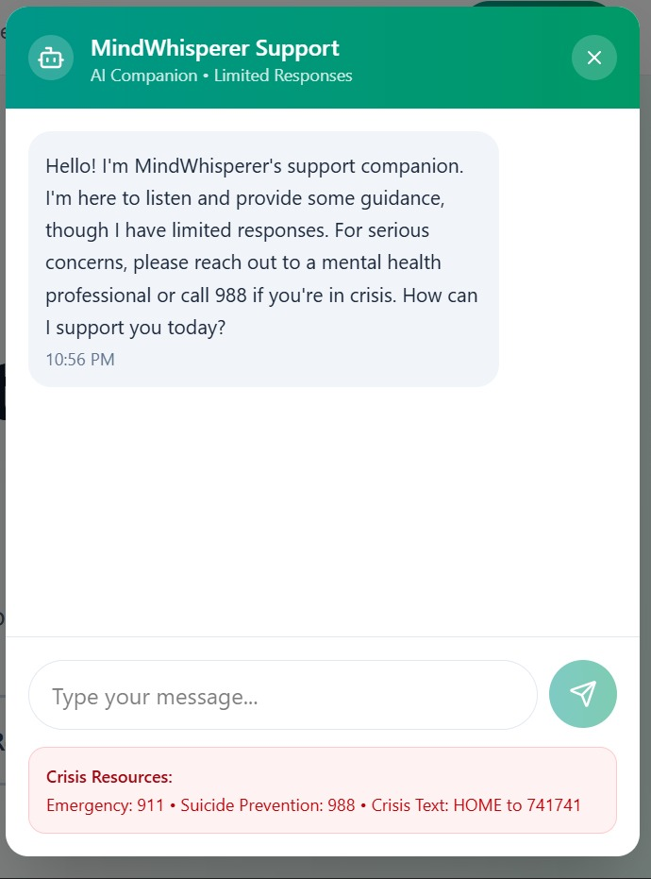

**RESULT**

As you explore the resources, communities, and support features within *MindWhisper*, we hope you find a platform where understanding, empathy, and healing can flourish. Whether you’re here to seek comfort, connect with peers, share your experiences, or simply discover tools to support your mental well-being,

*MindWhisper* provides a safe and welcoming space for everyone to feel heard and supported. Our goal is to build a community where individuals grow stronger together, guided by compassion and resilience.

The simplicity and warmth of *MindWhisper’s* interface ensure that every interaction—whether reading an article, joining a discussion, or chatting with a volunteer—carries meaning. We’ve designed the platform so that users can easily access resources, while also finding strength in the voices and stories of others. Every shared thought, word of encouragement, or act of listening contributes to a supportive environment where no one has to face challenges alone.

Each conversation on *MindWhisper* is more than just words—it’s an opportunity for connection and healing. By engaging with the community, supporting others, or reaching out when you need help, you ensure that every individual’s journey is recognized and valued. Whether you come here to find guidance or to offer it, *MindWhisper* encourages participation that goes beyond support—it’s about building trust, hope, and meaningful human connections.

As you contribute your voice, share your story, or simply lend an ear, remember that your presence helps shape *MindWhisper’s* culture. The platform thrives on kindness and active engagement, and every message, resource, and interaction strengthens the community spirit. *MindWhisper* isn’t just about mental health support—it’s about creating lasting connections that inspire hope, nurture resilience, and remind us that healing is never a journey taken alone.

# References:

1. Express.js Framework

* Website: Express.js Official Website

1. EJS Templating Engine

* Website: [EJS Documentation](https://ejs.co/)

1. MongoDB Database

* Website: [MongoDB](https://www.mongodb.com/)

1. Mongoose ODM (Object Data Modeling)

* Website: Mongoose Documentation

1. Node.js

* Website: [Node.js Official Website](https://nodejs.org/)

1. Passport.js (for Authentication)

* Website: Passport.js Documentation

1. GitHub (Version Control & Collaboration)

* Website: [GitHub](https://github.com/)

1. W3Schools (Tutorials & References)

* Website: [W3Schools](https://www.w3schools.com/)

1. Stack Overflow (Community Assistance)

* Website: [Stack Overflow](https://stackoverflow.com/)